

UNIVERSITY OF FRONTIER TECHNOLOGY, BANGLADESH
DEPARTMENT OF CYBER SECURITY ENGINEERING
PROJECT PROPOSAL

PROJECT TITLE:
PROJECT “BRO” - A STEALTH-ORIENTED MODULAR THREAT-SIMULATION ENGINE.
COURSE NAME: Object Oriented Programming Language Sessional
COURSE CODE: PROG 112

SUBMITTED TO
MD. MASUD RANA
Lecturer
Department of Cyber Security Engineering (CySE)

SUBMITTED BY
SHAWON SAHA RAJON | MD. ABDULLAH IBN HASAN
ID: 2404009 | ID: 2404016
Level:1 Term:2 | Level:1 Term:2

PROJECT “BRO” — A STEALTH-ORIENTED MODULAR THREAT-SIMULATION ENGINE
1) Abstract
The "BRO" engine is a high-performance, modular threat-simulation framework developed in C++. Unlike traditional monolithic scripts, this project utilizes Object-Oriented Programming (OOP) paradigms to decouple threat logic from the execution engine. By implementing Dynamic API Resolution and Polymorphic Design Patterns, the engine simulates advanced post-exploitation tactics, including process management, persistence mechanisms, and automated data exfiltration. This research explores the efficacy of current heuristic and AI-based detection systems against obfuscated, modular security threats.

2) Core Technical Objectives
- Modular Architecture: Implementing a robust MalwareModule interface to facilitate rapid threat-simulation prototyping.
- Detection Evasion: Utilizing Dynamic API Loading and Junk Code Injection to bypass static signature-based analysis.
- Persistence Mechanics: Simulating registry based re-entry to demonstrate long-term system compromise vectors.
- OOP Robustness: Leveraging Abstraction, Inheritance, and Polymorphism to ensure the engine remains extensible for future security research.

3) Proposed Methodology
The project follows a three-layered approach:
- Engine Orchestration: A central framework that manages the lifecycle of threat modules using late-binding polymorphism.
- Stealth Layer: Modules are designed to avoid hardcoded Windows API calls, instead resolving system functions at runtime to invalidate common detection patterns.
- Behavioral Simulation: Implementing real-world malicious behaviors (e.g., automated registry modification, process termination, and memory-based operations) within a sandboxed testing environment.
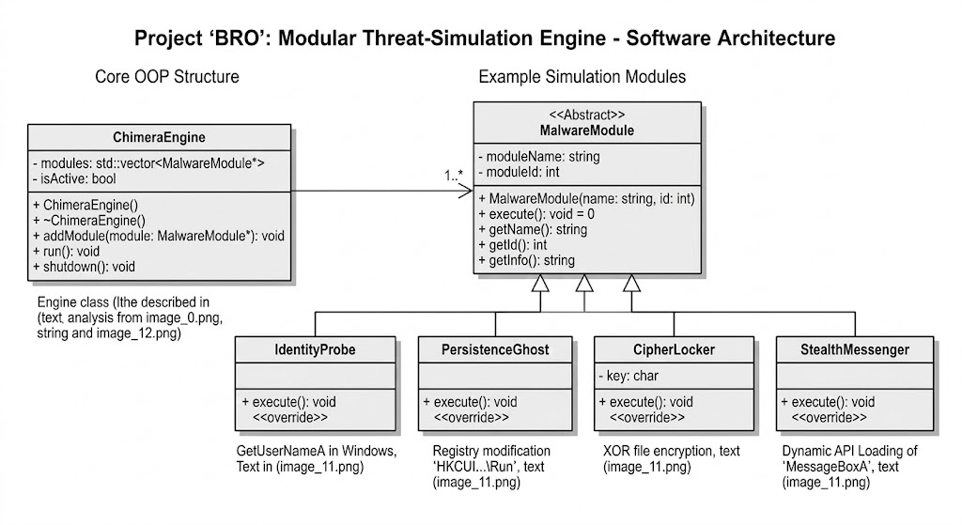
4) Technical Specifications
Language: C++ (Standard C++17/20)
Architecture: OOP-based Modular Framework
Persistence Strategy: Windows Registry (HKCU\...\CurrentVersion\Run)
Evasion Techniques: Dynamic Function Resolution, String Obfuscation, and Noise Loop Injection.

5) Educational Outcome
This project provides a comprehensive understanding of how modern threat actors design scalable, undetectable frameworks. By reversing the role from defender to attacker, we gain critical insights into developing more resilient, signature-independent defensive systems.

This Project is strictly for academic research and behavioral simulation within a controlled laboratory environment.

